











ASSIGNMENT

SUBMITTED BY
D V GARGI

1.INTRODUCTION

This security assessment was conducted to evaluate the security posture of an authorized target system. The objective was to perform host discovery, port scanning, OS detection, packet analysis, and identify security risks while adhering to ethical hacking principles. All scanning activities were performed within permitted scope and followed legal and professional guidelines.

2 . OBJECTIVES
- Identify last hosts on the network.
- Discover vulnerable ports and running services.
- Detect the operating system .
- Analyze network traffic using Wireshark.
- Identify security exposures.
- Provide mitigation recommendations

3. TOOLS USED
- Tool Purpose.
- Ping Host discovery.
- Nmap Port scanning .
- service detection .
- OS detection.
- Wireshark Packet capture and analysis

Task 1 - Host Discovery

Command Used:

ping 45.33.32.156

Explanation:
The target responded to ICMP echo requests, confirming it is active. TTL and response time provide network performance and OS hints.
SCREENSHOT:
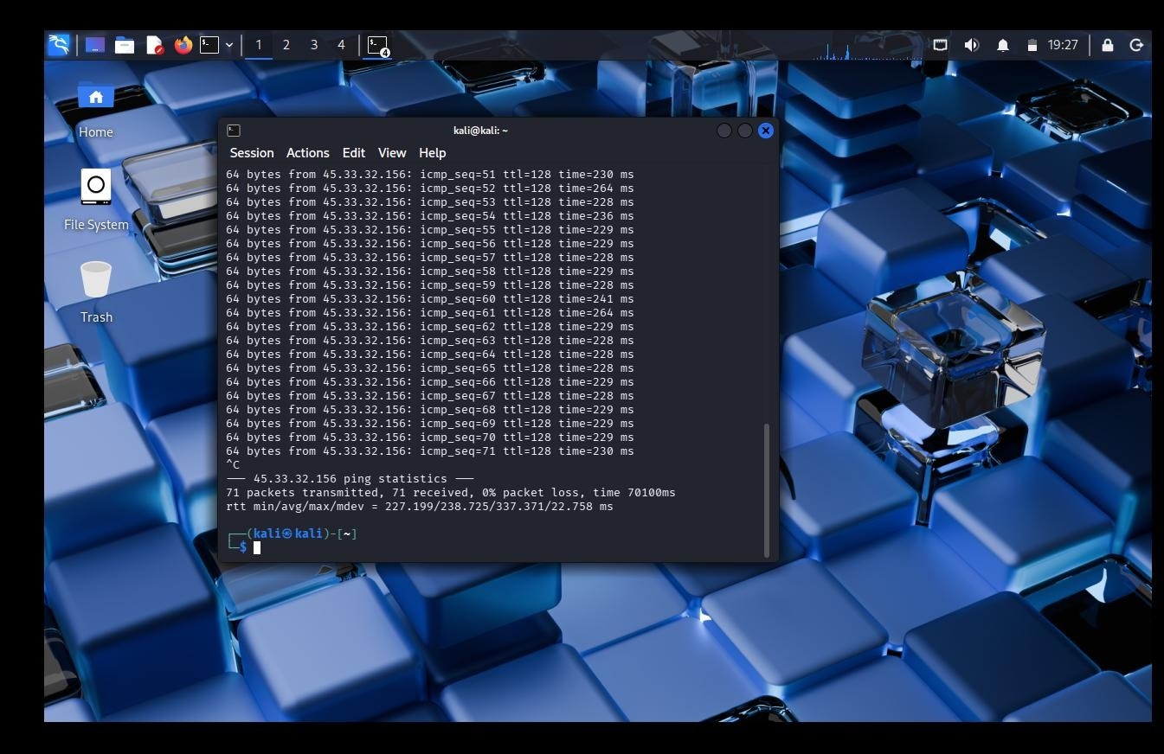

- Port Scanning

Command Used:

Nmap -F 45.33.32.156

Explanation:
The scan identified open ports, revealing accessible services. This helps determine potential attack entry points.

Port State Meaning
22 Open SSH remote login
80 Open Web server

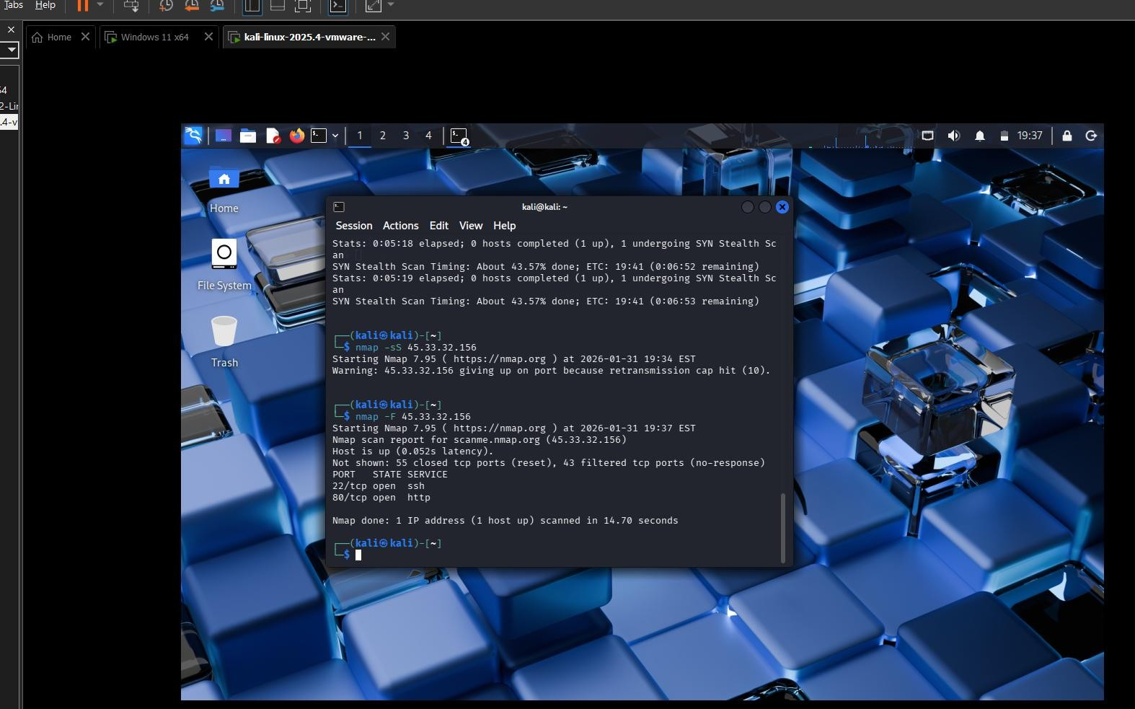

Task 3 - Service Version Detection

Command Used:

nmap -sV -T2 45.33.32.156

Explanation:
Service detection attempts to identify software versions running on open ports. The target showed “tcpwrapped,” indicating protective filtering mechanisms.
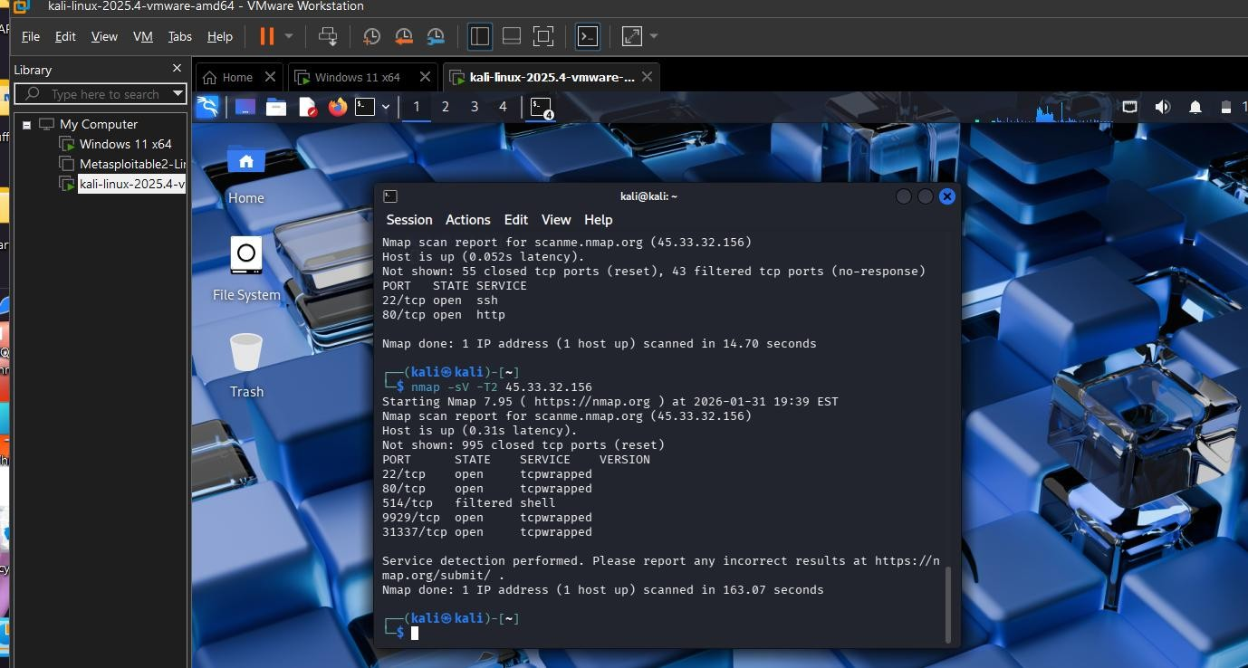

— OS Detection
Command Used: sudo nmap -O --osscan-limit -T2 45.33.32.156
Explanation:
OS fingerprinting suggested a Linux-based system. Some retransmission warnings occurred due to rate limiting, which is a security defense.

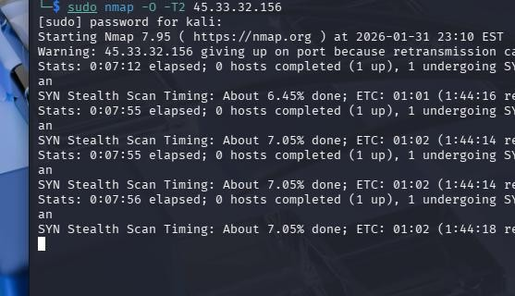

- Scan Without Ping

Command Used:

nmap -sS -Pn -F 45.33.32.156

Explanation
Even without ICMP replies, the scan identified open ports, demonstrating that blocking ping does not prevent scanning.
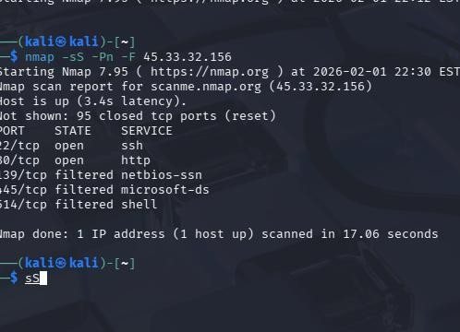

- Wireshark Packet Analysis

Filter Used:

tcp.flags.syn==1 && tcp.flags.ack==1

Explanation:
Wireshark captured SYN-ACK packets from the server, confirming open ports through
TCP handshake analysis.
SCREENSHOT:
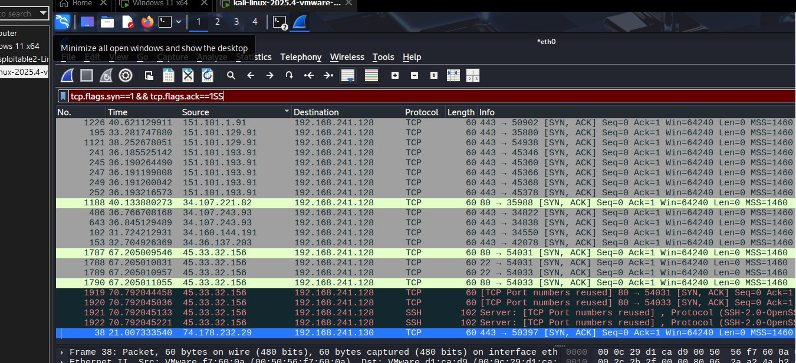

Findings | Risk
Open SSH (22) | Brute-force attack
Open HTTP (80) | Web exploitation
Service fingerprinting possible | Target profiling
Rate limiting  observed | Defensive mechanism present

Recommendations:
- Close unnecessary ports
- Restrict SSH access
- Keep services updated
- Use firewall and IDS
- Conduct regular vulnerability assessments

Conclusion

The assessment confirmed that the target system is reachable and exposes multiple services. Port scanning and packet analysis verified open ports and active services. While security controls such as rate limiting were observed, exposed services still increase attack surface. Proper hardening, monitoring, and patch management are essential to enhance security posture.

